Mental Health

Champions



**Resources to Implement the *Mental Health Champions* Training**

**Welcome!**

Thank you for taking this step to learn more about youth mental health. It’s an important step to ensure our youth are safe and reaching their fullest potential. You are commended for your dedication to youth and their health. Give yourself a round of applause!

*A few notes before you dive in…*

* This handbook is a companion resource to the training, *Mental Health Champions (MHC)*. For more information on how to participate in a *MHC* training, contact your program coordinator.
* Please remember as you read this handbook, the objective is **not** to train you to diagnose mental illnesses. The purpose of the handbook is to provide you with the knowledge, awareness, and sensitivity for you to act as a positive, caring, and supportive adult for youth.
* The material covered in this handbook is only a small portion of all youth mental health and mental illness information. The topics were chosen to best serve your needs as an adult who works with youth. For information on mental illnesses or other topics not covered, refer to the resources page at the end of this handbook.
* You can use this resource handbook to meet your own needs. Read it all the way through, flip to sections that might be pertinent to a current situation, or reference the handbook when encountering something you aren’t sure how to handle. Let it guide your actions and reactions as you begin the journey of helping and assisting youth with their mental health.

**I’m ready! But what is mental health and mental illness?**

Mental health is not simply the absence of mental illness. It is the foundation of well-being and an important part of holistic health.

*“[Mental health is]…a state of well-being in which the individual realizes his or her own abilities, can cope with the normal stresses of life, can work productively and fruitfully, and is able to make a contribution to his or her community.” –World Health Organization*

Another way to think about mental health is as a spectrum. Everyone fits somewhere on this spectrum. Just as with physical health, everyone has mental health and needs to take steps to stay mentally healthy. Mental health may move around on the spectrum as you experience life. One part of your life might result in very positive mental health while another part may require you to call on additional support to manage a mental illness. It’s not constant and can be very situational.

Mental illnesses are conditions that cause changes in feeling, mood, or thinking. These changes are often accompanied by changes in behavior, and can affect a person’s ability to function in daily life.

Mental health spectrum

**Okay, but how many young people have a diagnosed mental illness?**

The graphic below should look familiar. It was developed by the National Alliance on Mental Illness, a trusted grassroots mental health organization. It’s important to note that the statistics on percentages of youth with mental health diagnoses depend on how each organization framed their research. Some organizations report **higher** or **lower** numbers than what you see below. Low reporting rates also make it **difficult to know how many youth have been diagnosed or are struggling with a mental illness**. The important thing to remember is that mental illnesses are fairly common in youth and adults. Mental illnesses can lead to limited educational opportunities, high unemployment, physical health risks, and death.

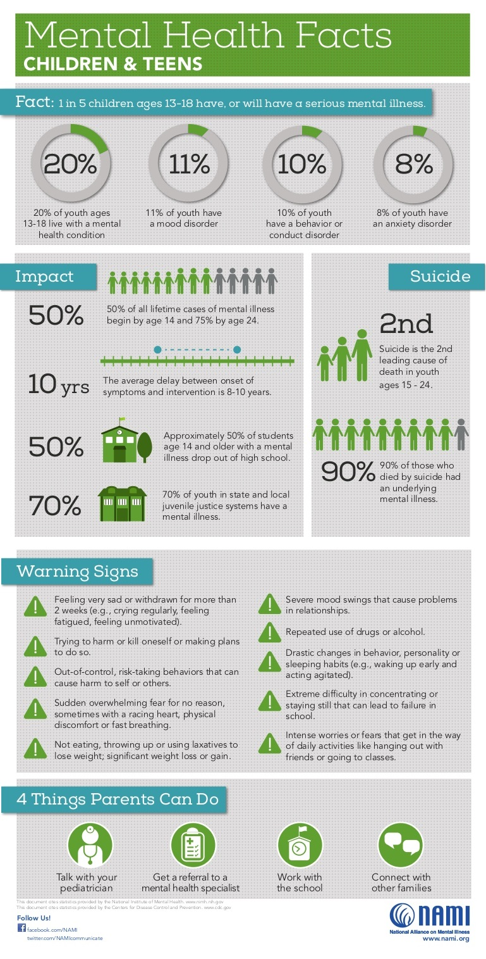

**Typical Development vs. Mental Illness**

T

he difference between typical developmental behaviors and behavior associated with a mental illness are often hard to tell apart. What separates the two are behaviors that **persist over time** and behaviors that **negatively affect daily life**. For example, it might be considered typical for a teenager to be irritable or to prefer to be alone. These behaviors should only be alarming when they last for weeks or create a nonfunctional daily life. If a child is tired and disinterested at one program or event, that’s probably nothing to be too concerned about. If they are consistently tired and detached over a period of months, there might be an underlying issue. Learning more about the ages and stages of child development may be useful in identifying atypical behavior. More information from the American Academy of Pediatrics can be found here: <https://www.healthychildren.org/english/ages-stages/Pages/default.aspx>

**Mental Illnesses**

This section will explore five mental illnesses commonly diagnosed in youth: anxiety, depression, substance abuse, eating disorders, and attention-deficit hyperactivity disorder (ADHD). The information below is an introduction to mental illnesses. The resources at the end of this document can help you find more information about each of the mental illnesses listed and many others. While you’re reading, keep in mind that mental illness can look very different in people with the same diagnosis. What might be true for one person can be false for another.

*Definitions that might be helpful:*

**Prevalence** – the commonness of an illness or disease in a population at any given time

**Psychotherapy** – a method in which psychological problems are treated through communication between a trained mental health professional and an individual

**Cognitive-behavioral therapy** – a type of psychotherapy in which the individual is taught to change their maladaptive thoughts and behaviors

**Co-occurring** – to occur at the same time

***Anxiety***

Many youth experience some anxiety during their development from a young age. The three different types of anxiety include separation anxiety, phobias, and social anxiety. How many youth are diagnosed with anxiety?

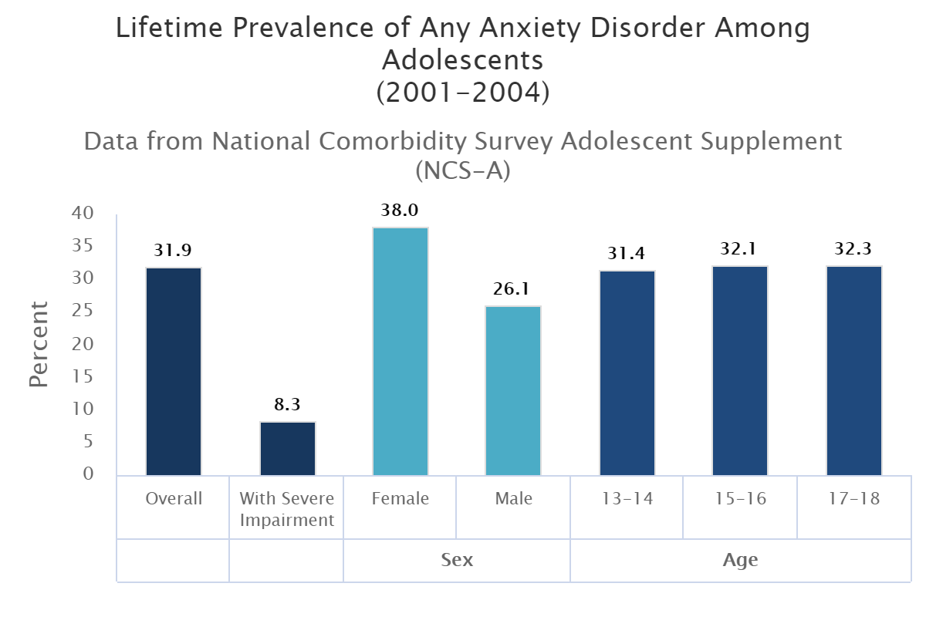

As you can see above, 31.9% of the youth who participated in the study reported anxiety diagnoses. You can also see that more females were diagnosed with anxiety than males. You might be thinking that this information seems quite old. Remember that mental illness statistics vary from organization to organization. And some organizations don’t collect data all that often. While it’s hard to say exactly how many youth suffer with anxiety, what we do know is that it’s a large number and one of the most commonly diagnosed mental illnesses in youth.

**Symptoms of Anxiety Disorders**

*Treatments*

Anxiety can be treated in youth. The earlier a child or adolescent can get help for anxiety, the better the outcome will likely be. Common treatments include individual psychotherapy, family therapy, medications, and cognitive-behavioral treatments.

*Remember*

* All feelings or emotions of young people are valid and should be taken seriously. Pushing youth that are experiencing anxiety or publicly noting their discomfort will probably not result in a positive experience. Supporting and encouraging them to participate can be helpful, understanding that a youth experiencing anxiety may need extra help accomplishing a task or activity.
* The help that youth may need will vary from medication to therapy to learning about coping strategies, or all three. Treatment is very individualized.
* Anxiety symptoms become serious when it affects functioning in daily life (e.g., at school, at home, among peers, etc.)

***Depression***

Just like anxiety, many young people may experience periods of depression or depressed states throughout development. Depression is the most diagnosed mental illness in youth.

Percentage of Youth Ages 12-17 Who Experienced a Major Depressive Episode (MDE) in the Past Year by Age and Gender, 2004-2015

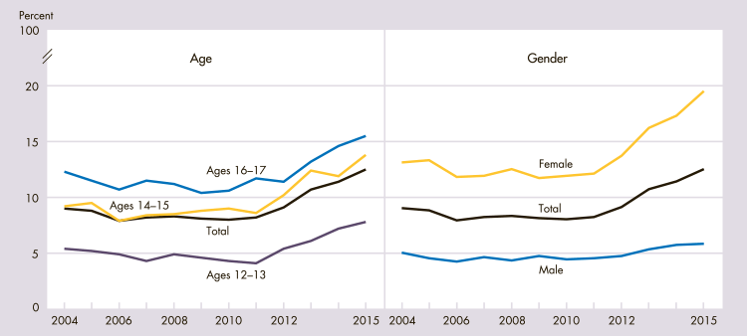NOTE: MDE is defined as a period of at least 2 weeks when a person experienced a depressed mood or loss of interest or pleasure in daily activities plus at least four additional symptoms of depression (such as problems with sleep, eating, energy, concentration, and feelings of self-worth) as described in the fourth edition of the Diagnostic and Statistical Manual of Mental Disorders (DSM-IV).  
SOURCE: Substance Abuse and Mental Health Services Administration, National Survey on Drug Use and Health

You can see above that from 2004 to 2015 the percentage of youth who experienced major depressive episodes has increased among males and females as well as across all age groups.

**Symptoms of Depression**

*Treatments*

Depression can be treated and the earlier it is diagnosed, the better the likely outcome. Common treatments include a combination of medication and different therapies including individual and family therapy.

*Remember*

* You should watch for behaviors that persist over time. If a youth in your program is having a bad day and seems a bit down, that is different from a young person who doesn’t seem to find joy in activities they previously enjoyed.
* Many youth experience depression at some point during their development. There are risk factors that may make it more likely that a youth will develop depression; we will go into more detail later.
* Youth experiencing depression might be scared about why they feel the way they do. Be supportive and validate their feelings.

***Substance Use Disorder***

Substance Use Disorder is a growing concern and comes in many different forms. Six common substances associated with this disorder include: alcohol, tobacco, cannabis, stimulants, hallucinogens, and opioids. Substance Use Disorder is often co-occurring with other mental illnesses like depression and anxiety.

**Alcohol or Illicit Drug Use among Adolescents, 2015**

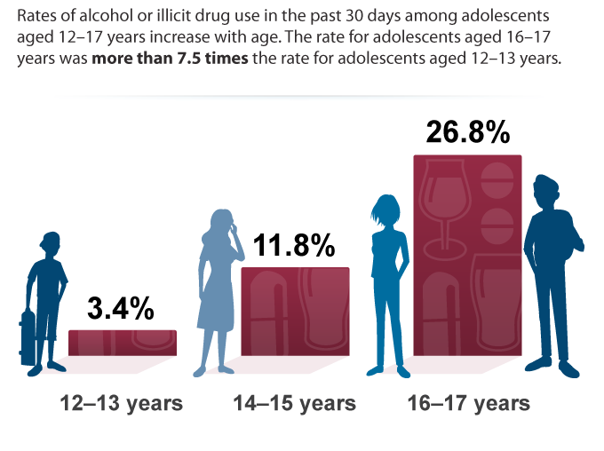

**Data source:** National Survey on Drug Use and Health (NSDUH), SAMHSA.

The numbers above are predicted to increase with the growing opioid crisis across the United States. Young people with substance abuse disorder need support and guidance to address their dependency on substances.

**Symptoms of Substance Abuse Disorder**

|  |  |
| --- | --- |
| Feeling that they must use the drug regularly, daily or several times a day | Doing things to get the drug that they normally wouldn’t do, such as stealing |
| Intense urges for the drug that block out any other thoughts | Doing risky activities when they are under the influence of the drug |
| Over time, needing more of the drug to get the same effect | Spending a good deal of time getting, using, or recovering from the drug |
| Taking larger amounts of the drug over a longer period than they intended | Continuing to use the drug, even though they know it’s causing problems or physical and psychological harm |
| Making certain they maintain a supply of the drug | Failing in their attempts to stop using the drug |
| Spending money on the drug, even when they can’t afford it | Experiencing withdrawal symptoms when they attempt to stop taking the drug |
| Not meeting obligations and responsibilities | New friend groups with similar substance dependency issues |
| Cutting back on social and recreational activities, or activities they used to enjoy | Family substance abuse |

*Treatments*

Because of the co-occurring illnesses that often come with substance abuse disorder, many times only one illness is treated at a time. Treatment for substance abuse disorder is very complex and can contain many different components. Adult treatments include individual and group counseling, inpatient and residential treatment, intensive outpatient treatment, partial hospital programs, case or care management, medication, recovery support services, 12-Step fellowship, or peer supports. For youth, treatment might include these components but also includes residential treatment centers and removing the youth from their home.

*Remember*

* Treating substance abuse disorder takes a village. If it is not treated, substance abuse disorder will only continue to increase risk for the individual.
* Treatment for substance abuse disorder often takes time, intense involvement, and dedication. Individuals will be in recovery for the rest of their lives.
* Because of the nature of the disorder, substance use often leads to risky and dangerous activity. It is imperative they find help.

***Eating Disorders***

The four eating disorders that are most common in youth include anorexia, bulimia, binge eating disorder, and compulsive overeating. Anorexia is associated with low body weight. Bulimia is associated with binging a large amount of food and then purging. Binge eating disorder and compulsive overeating are associated with an obsession with food that leads to consuming large amounts of food. Eating disorders are more common in females but males are also diagnosed.

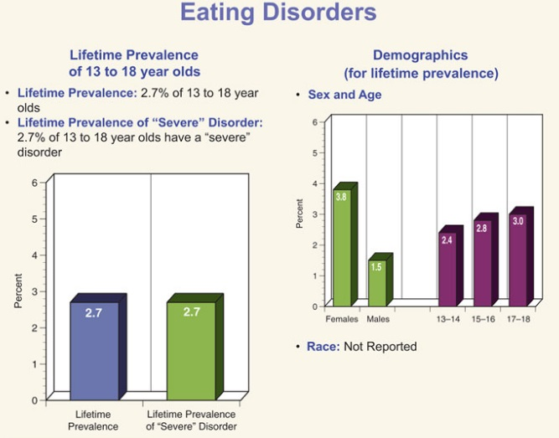

Source: National Comorbidity Survey – Adolescent Supplement (NCS-A)/ 2004

You might be thinking that the prevalence of eating disorders is quite low when compared to the other illnesses. Regardless of the numbers, if eating disorders aren’t treated, they can be fatal.

**Symptoms of Eating Disorders**

*Treatment*

Comprehensive and early treatment for youth with eating disorders is very important for successful outcomes. The most common form of intervention is admission to eating disorder treatment centers and cognitive-behavioral therapy.

*Remember*

* When talking to youth (or anyone) with an eating disorder, it’s important to think about your words before you say them. Your words can drastically affect their opinion of themselves. For example, if you notice a young girl ignoring her snack or eating too much, you shouldn’t bring attention to it, especially in front of a group of peers.
* You can help support all youth to feel relief from the pressure of social media by introducing activities that encourage positive self-esteem.

***Attention-Deficit Hyperactivity Disorder (ADHD)***

Many children and youth may exhibit behaviors that reflect typical developmental patterns of appearing to have non-stop energy, constant movement, and difficulty focusing. Only those with extreme age-inappropriate challenges in these areas would qualify for an ADHD diagnosis.

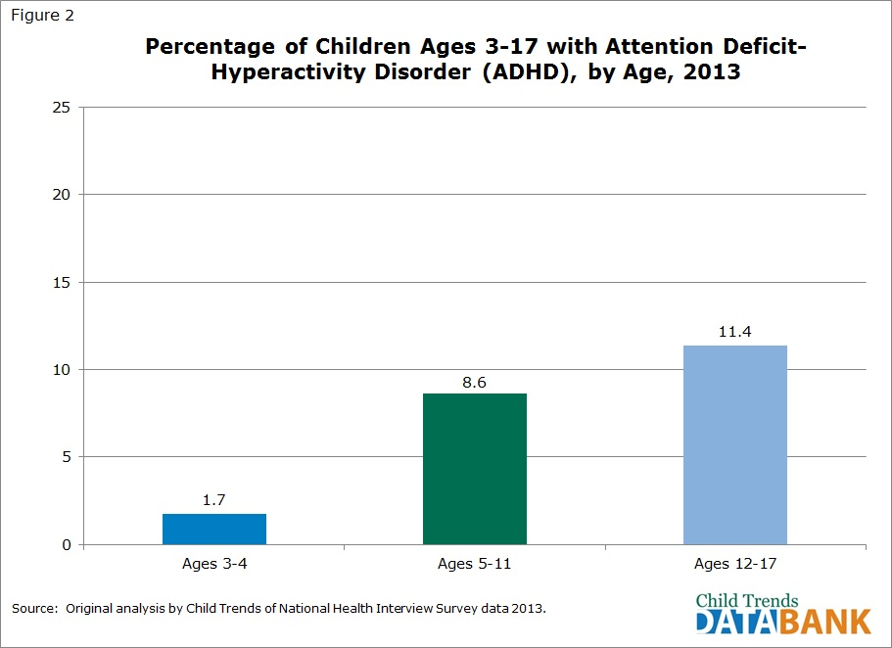

There is disagreement about the exact number of youth diagnosed with ADHD. Many feel that it is either over or under diagnosed. Remember that you are not qualified to make this distinction. Simply support the youth the best way you know how and adapt activities to best suit his or her needs.

**Symptoms of ADHD**

|  |  |
| --- | --- |
| Aggression | Forgetfulness |
| Excitability | Problems paying attention |
| Fidgeting | Short attention span |
| Hyperactivity | Anger |
| Impulsivity | Anxiety |
| Irritability | Depression |
| Lack of restraint | Learning disability |
| Persistent repetition of words or actions | Boredom, excitement, or mood swings |
| Absentmindedness | Difficulty focusing |

*Treatment*

Treatment can help reduce and manage the symptoms of ADHD but it is unlikely they will ever be entirely eliminated. Treatments include therapies, medications, and specialists.

*Remember*

* ADHD requires a medical diagnosis. Not every youth that can’t sit still in your activities and events will be diagnosed. There is a fine line between the “typical” behavior we discussed earlier and behavior that constitutes a mental illness.
* You may need to adapt your activities to best serve your youth. Many young children have a hard time focusing or sitting still, regardless of an ADHD diagnosis. Perhaps you could change the way programs are delivered so that the youth are better able to be attentive.
* If your program or activity is overnight, keep in mind some youth will need to take medications to maintain behavior and emotion control. Many programs already have a nurse in place to deliver these medications. Just keep in mind how skipping medications or not taking them at the right time might affect a child’s behavior.

**Risk Factors**

T

he risk factors for developing a mental illness vary across the different mental illnesses, but there are similar themes. The risk factors discussed here are not all the possible risk factors. In fact, you may notice several factors that aren’t listed. The aspects we will be focusing on were selected because as volunteers in your community, these are the factors **you might see** in youth. In addition, your position in the community allows you to know what is going on in the homes and lives of your youth. With these things in mind, you might notice a potential risk that others do not.

Another thing to remember is that just because a young person has one or more of these risk factors **does not necessarily mean** that they are experiencing a mental illness. It simply means they are at greater risk of poor adjustment and potential mental illness. This list is something to keep in mind as you are listening to and interacting with your youth. For example, you might be aware that a young person is experiencing their parent’s divorce which is a risk factor for mental illness. Knowing this, **you can provide a little more support** for that youth without raising undue alarm. Below is a list of risk factors for developing mental illness.

* low self-esteem
* difficulties in communicating
* chronic medical illness
* substance abuse
* loneliness
* grief
* neglect
* family conflict
* exposure to violence or abuse
* low income and poverty
* difficulties at school
* poor access to basic services
* injustice
* social and gender inequalities
* exposure to disaster and trauma

Another associated risk factor for potential mental illness is youth who identify as lesbian, gay, bisexual, transgender, or questioning (LGBTQ). Identifying as LGBTQ is often associated with mental health concerns due to issues with family acceptance, low self-esteem, confronting prejudice and stigma, discrimination, abuse, and bullying. In fact, LGBTQ youth are **two to three times** more likely to develop a mental illness like depression and anxiety than heterosexual youth.

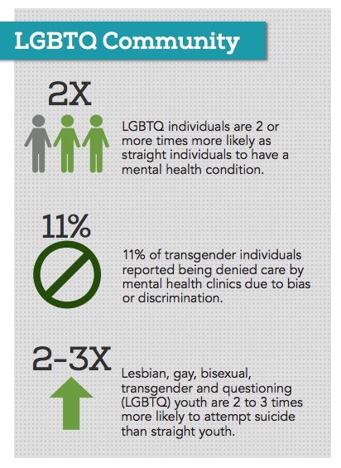

**Strategies for Promoting Positive Mental Health**

P

romoting positive mental health depends on the individual and their circumstances. There are several strategies that have been found to help promote positive mental health. The focus of this section is on the Essential Elements of 4-H programming, boosting protective factors, and supporting mindful practices.

Depending on the program you work or volunteer with, you might be familiar with the concept of **positive youth development.** Positive youth development focuses on intentional programming that youth need to be successful. Eight key components of positive youth development include physical and psychological safety, supportive relationships, opportunities to belong, support for efficacy and mattering, positive social norms, opportunities for skill-building, appropriate structure, and integration of family, school, and community efforts.

How does this tie into positive mental health? Many of the protective factors and elements **also promote positive mental health**.

**Essential Elements**

The Essential Elements were developed based on standards of practice that all youth development programs should follow or implement. They were created as a **framework for 4-H positive youth development** programming specifically in mind but the curriculum can be adapted to other youth development programs. As you read this section, think about the things that you are already doing in your program and **things you could do to improve** in each of the eight Essential Elements.

|  |  |
| --- | --- |
| **Essential Elements of Positive Youth Development** | |
| **Belonging**  1. Positive Relationship with a Caring Adult  2. An inclusive environment  3. A safe environment | **Mastery**  4. Engagement in Learning  5. Opportunity for Mastery |
| **Independence**  6. Opportunity to see oneself as an active participant in the future  7. Opportunity for self-determination | **Generosity**  8. Opportunity to value and practice service for others |

You’ll notice that the elements are split into four different subgroups, **belonging, mastery, independence, and generosity**. As you read through the description of each element on the next page, think about which category you might need to work on the most in your program.

|  |  |  |
| --- | --- | --- |
| **Essential Element** | **Description** | **Related to Mental Health** |
| **Positive Relationship with a Caring Adult** | youth have an adult who they can depend on and with whom they feel safe and secure | positive role models, support from adults |
| **An Inclusive Environment** | youth feel like a valued and equal member of a group regardless of their background, beliefs, or any other factors | validation of feelings and beliefs, support |
| **A Safe Environment** | youth feel safe from harm, injury, or ridicule | safety from harm |
| **Engagement in Learning** | youth are actively engaged in their learning and are encouraged to explore things that interest them | exploring interests |
| **Opportunity for Mastery** | youth gain skills and mastery over a subject | build self-esteem |
| **Opportunity to See Oneself as an Active Participant in the Future** | youth can see a positive outlook for them in the future | visioning and creating positive outlook |
| **Opportunity for Self-determination** | youth set their own goals | setting goals |
| **Opportunity to Value and Practice Service for Others** | youth have the opportunity to give back in meaningful ways | proven to improve mood and self-esteem |

You can use the Essential Elements Curriculum to incorporate these important elements into your programs found here- <https://fyi.uwex.edu/wi4hstem/files/2015/02/full-training-curriculum-and-appendices.pdf>

**Protective Factors**

There are other protective factors that help promote positive mental health. They include ability to solve problems and manage stress, support of family and friends, good parenting/family interaction, physical and economic security or safety, school achievement, access to basic services, and social and gender equality.

From this short list of protective factors and the information about essential elements, we can draw on **three key themes** that you should keep in mind when interacting with your youth.

1. **Building confidence – low criticism, high encouragement** 
   * By providing youth with high encouragement, it helps to build their confidence in themselves and their abilities. Low criticism doesn’t mean they get rewarded for everything. It means that when you do provide criticism, it’s **helpful and constructive**.
2. **Provide guidance and discipline – rules and consequences/ provide structure** 
   * + Young people need some structure in their lives. It helps them to understand when things happen and why they happen. If you co-create the rules with the youth, **they’ll feel empowered** to abide by them. And by deliberating reasonable consequences before there’s an issue, you and the youth will know what to expect at all times.
3. **Safe surroundings – free from bullies and other concerns** 
   * + Create an environment **free from bullying** and other emotionally harmful behaviors. It’s very important in building positive mental health!

**Mindfulness**

Mindfulness has roots in Buddhist meditation but has grown in popularity in Western cultures in recent years. Mindfulness is the **ability to be present**, be aware, and not be overwhelmed with whatever is happening around you. It **takes practice** to utilize this skill for better outcomes in life. Mindfulness is shown to have many benefits for positive mental health, listed below:

* Reduced overthinking
* Reduced stress
* Increased focus
* Increased memory
* Reduced emotional reactivity
* Relationship satisfaction, better connections
* Self-insight and confidence
* Understanding pain and personal emotions

The main pillar of mindfulness is meditation but there are several ways to be more mindful and reduce stress reactions without meditation. Below is a chart that shows some of the many ways you can practice mindfulness.

|  |  |  |
| --- | --- | --- |
| Observing your breath, bringing attention to it in times of stress | Chew your food slowly and savor each bite | Before starting your day, write down top 3 priorities |
| Mediation | Reflecting on your goals | Listen to music |
| Take 5 deep, slow breaths | Journal – reflection of each day, things that bother you, things you are grateful for | Show appreciation to those around you with cards or words |
| Observe your thoughts and emotions throughout the day | Spend time in nature without distractions | Yoga or other exercise that encourages body awareness |

**PLANS**

Y

ou might be thinking to yourself, “All this is helpful information but what can I actually do to help my youth?” Excellent question. As was mentioned earlier, you play a unique role in the lives of your youth. As a caring, supportive, and positive role model, **you have the power** to help improve a youth’s situation. What actual steps can you take to care for your youth? PLANS. PLANS stands for People-first language, Listen intently, Assess situation/ share resources, Never diagnose, and (be) Supportive and kind. When addressing a situation or a youth with a potential mental health difficulty, use these steps to guide the process.

**1. People-first language-** This first step sets the foundation for empathy. When we talk about mental illness or disabilities, people-first language establishes that a person is simply that, a person. With or without a diagnosis people have the right to be treated as such without judgement or stigma. This is the difference between saying that someone has an illness and someone is an illness. For example, it is the difference between saying that someone *is* schizophrenic as opposed to saying that he/she *has* schizophrenia. When talking about mental illness, always remember that the person you are talking to deserves to be treated with respect and kindness.

**2. Listen intently-** When you first interact with or approach a youth, you should always be prepared to listen intently. While you may think you are a great listener, it is always a good idea to refresh your training on what it means to be a good listener. Refer to the chart below for a list of behaviors that would indicate you are or are not listening.

|  |  |
| --- | --- |
| **Listening** | **Not listening** |
| * Head nodding * eye contact * repeating information back to speaker * ask questions, BUT don’t dominate or over-direct the conversation * attentiveness * not letting your own perceptions cloud your thoughts about what you’re hearing | * Looking at phone or other distractions * finishing sentences or interrupting * hurrying a conversation along * not listening to responses * comparing their problems to your own |

The next time you have a conversation with someone, really pay attention to how well you are listening. Are you asking appropriate questions but allowing them to communicate their thoughts without interruptions? Are you completely focused on them or distracted by a million other things?

Did you let your thoughts cloud your perceptions of what they’re saying instead of actually hearing? Actively work on your listening skills and put them to good use when a youth needs your attention.

**3. Assess the situation/ share resources-** As you are talking with the youth, you will hopefully learn many things that will help with this step. For example, maybe you have a youth who is telling you that they are confused about some feelings they have been having. You assess that at this moment they need a website where they can find more information. Perhaps you have a youth who needs help finding a counselor. Do what you can to assist and provide reassurance and validation. By allowing youth to express themselves and have a conversation in a nonjudgmental and supportive way, you will help the youth to feel validated. This can be very liberating and helpful to someone dealing with a mental illness, or any situation. Allow them to feel unashamed about themselves.

**4. Never diagnose-** As mentioned several times in this handbook, never try to diagnose. The knowledge you now have about mental health and mental illness should serve as background information to help you in situations of need. Unless you are trained and qualified, please do not attempt to diagnose.

**5. (be) Supportive and kind-** Throughout the process, be compassionate and kind and act as a caring adult to be supportive through a difficult time.

**Suicide**

T

here are two topics that were not discussed in the training: suicide and bullying. As mentioned earlier, **suicide is the second highest cause of death** among adolescents. You may encounter a youth who is considering attempting suicide or having suicidal ideation. It’s important to know how to talk to youth in this precarious situation.

Remember-

* You should take all threats and talks of suicide seriously. You may have heard that youth who talk about suicide only want attention. They not only might want it, they might need it. Therefore, take any and all talk of suicide very seriously.
* Try to be calm and reassuring. They need you to be strong and calm. This means talking slowly and keeping emotion out of your voice.
* Do not leave the youth alone or let them leave you until you are sure they have someone else to stay with them or until they receive the help they need. It may be uncomfortable but you should tell their parents or guardian what you have learned about their suicidal thinking.
* Ask them if they have a plan for suicide. From this conversation you can discern how quickly they are planning on going through with it. Don’t delay in getting help, regardless.
* In a crisis where youth are harming or threatening to harm themselves, threatening to harm others, or sharing experiences of physical or mental abuse, report it to the appropriate authorities (Police- 911, ChildLine- 888-761-5525).

**Bullying**

A

s you are probably aware, bullying is a problem that youth encounter at school, online, and, unfortunately, sometimes in your programs or activities. Not only is bullying a problem for the victim, but it is likely the bully has mental health issues as well. That is why it is so important to create a safe and inclusive environment for your youth. Below are several tips for creating a safe and inclusive environment.

* Set ground rules about respecting others and others’ cultures.
* If you have the opportunity to develop programming or activities, make an effort to include examples from other cultures, genders, and social groups. It’s even better if you can bring in guests to share about those cultures.
* Create opportunities for youth to work in groups and make sure the groups are mixed across gender, age, culture, and experiences.
* Address inappropriate comments immediately.
* Make sure your activities and programs are accessible to youth with disabilities. You’ll send a message of inclusivity to your youth.
* Spend extra time and care with the youth that are bullying others or are victims of bullying. Try to find the root cause of their behavior and offensive actions against others.
* Make sure that you’re consistent with your consequences for bullying and that your intentions are clear.
* Use team building activities to enforce teamwork and provide opportunities for youth to show appreciation for the skills and knowledge that each youth has.
* Have a plan in place for how you will manage bullying ahead of its occurrence. Your program director might already have a plan in place. This will ensure that you know exactly what to do when faced with an issue.

This website, <http://diversity.arizona.edu/creating-inclusive-classrooms>, is a great resource for more information about how to create an inclusive environment.

**Other Information**

**Phrases That Aren’t Helpful**

|  |  |
| --- | --- |
| **Phrase** | **Why it’s not appropriate** |
| Don’t feel sad, nervous, stressed, etc. | Don’t tell youth how to feel about anything. Their feelings are valid, as is. |
| You don’t need medication. | You are not qualified to make this call unless you are a trained psychiatrist. |
| It’s not so bad. | Again, their feelings are valid. Don’t try to give them perspective this way. |
| Are you doing this for attention? | ***Never*** say this. Even if you suspect they want attention, that’s a red flag for underlying issues. |
| If you pray hard enough… | It is not appropriate to talk about religion with youth in your programs. |
| We’re out of time today. | Don’t move on or ignore youth’s attempt to connect or a cry for help. |
| When I was your age… | When youth are in distress, it probably isn’t helpful to provide examples from your life. It might be tempting to but please refrain from “comforting” in this way, as you want to focus on the youth, not yourself. |
| You seem fine. | We are all capable of hiding feelings. Young people will hide things from their friends and family. |
| You must be acting this way because of your mental illness. | Not everything can or should be attributed to a mental illness. |

**Conversation Starters and Phrases of Support**

It might be intimidating to start a conversation about mental health, especially with youth. Remember your listening skills and don’t put words in their mouth. Don’t promise to keep secrets from their family or professional help. Try to avoid yes or no questions. Based on your initial conversation, you can assess how you might approach their parents or family. Below is a list of conversation starters and phrases of support you can use with youth.

* **I’m worried about you. How have things been going lately?**
* **How are you?**
* **I noticed (insert concerning behavior). What’s going on?**
* **You aren’t alone.**
* **What’s on your mind?**
* **If you would like to talk about anything, I’m here to listen.**
* **That sounds really hard, I’m sorry you’ve had to deal with that.**
* **I hate to see you struggling like this. I know of some resources that might help.**
* **Who have you talked to about these things?**
* **So, tell me about…**
* **Let’s talk about how we can work to make this better…**
* **The last time I saw you, you told me this was bothering you. Any updates?**
* **What would you like to change/see happen in this situation?**
* **I’ll check in next week to see how things are going!**

**Activities Appendix**

**Mindfulness Journaling**- This activity can be done with your youth if you have approximately 5-15 minutes. The supplies you will need include paper and writing utensils. Refer to mindfulness section for more information.

Step 1. Have your students fold their paper in half.

Step 2. On one side, have them write five things that stress them out in that moment.

Step 3. On the other side, have them write five things they like about themselves in that moment.

If you have time, you might take them through quick reflection period where you ask why it might be harder to write things that stress them out over things that they love about themselves. This activity should encourage youth to think about how they react to stressors.

**Thumbs Up- Thumbs Down**- This activity can be done very quickly at any point in your program or activities.

Step 1. Ask your students how they are feeling and to give you a thumbs up or thumbs down or somewhere in the middle.

**Mindfulness Breathing**- Lead youth through 5 deep, slow breaths. Have them focus on each breath and clear their mind of all other thoughts.

**References and Resources**

Provided below is a list of websites and reputable sources where you can find more information on the topics covered in this handbook or view the references used to create the *Mental Health Champions* curriculum. Also listed are several hotlines and resources for you to hand off to youth who might need additional support.

**Telephone Support Numbers**

* **National Suicide Hotline**: 1-800-SUICIDE (784-2433) or the National Suicide Prevention Lifeline: 1-800-273-TALK (8255)  
  Both toll-free, 24-hour, confidential hotlines which connect you to a trained counselor at the nearest suicide crisis center.
* **Safe Place**: 1-888-290-7233  
  Project Safe Place provides access to immediate help and supportive resources for young people in crisis through a network of qualified agencies, trained volunteers and businesses in 32 states. Online at nationalsafespace.org.
* **National Alliance of the Mentally Ill**: 1-800-950-6264  
  Toll-free, confidential hotline operating Mon.-Fri., 10 am- 6 pm (EST). Trained volunteers provide information, referrals, and support to anyone with questions about mental illness.
* **Youth America Hotline:** 1-877-968-8454 (1-877-YOUTHLINE)  
  Counseling for Teens by Teens
* **The Trevor Project**: 866-4-U-TREVOR  
  Around-the-clock crisis and suicide prevention helpline for lesbian, gay, bisexual, transgender and questioning (LGBTQ) youth. The Trevor Helpline is available as a resource to parents, family members and friends of young people as well. Visit [www.TheTrevorProject.org](http://www.thetrevorproject.org).
* **Suicide Prevention Lifeline:** 1-800-273-8255  
  The Web site for this 24-hour, confidential hotline offers details about how to call if you need help, how to identify suicide warning signs, and information for veterans experiencing mental distress. Visit [www.suicidepreventionlifeline.org](http://www.suicidepreventionlifeline.org).

**Websites**

* **The Jed Foundation**

([www.jedfoundation.org](http://www.jedfoundation.org))   
The Jed Foundation works to reduce the stigma students feel about having or seeking treatment for emotional problems.

* **Mental Health America**

(<http://www.mentalhealthamerica.net/finding-help>)

Mental Health America is a nonprofit that works to address the needs of those with mental health difficulties. They can connect you to local resources, provide screening tools, and gives more information. Mental Health American also has a crisis line. Call: 1-800-273-8255 or text MHA to 741741.

* **Mindful**

([www.mindful.org](http://www.mindful.org))

Mindful is a non-profit organization that provides more information and resources on the practice of mindfulness.

* **The National Institute of Mental Health**

(<https://www.nimh.nih.gov/health/index.shtml>)

* **Teen Mental Health**

([www.teenmentalhealth.org](http://www.teenmentalhealth.org))

* **U.S. Department of Health and Human Services** (<https://www.hhs.gov/ash/oah/adolescent-development/mental-health/mental-health-disorders/index.html>)
* **Substance Abuse and Mental Health Services Administration (SAMHSA)** (<https://www.samhsa.gov/children>)

SAMHSA has youth education materials for specific mental health diagnoses.

* **Youth Power**

([www.youthpower.org](http://www.youthpower.org))

Youth Power is a branch of the United States Agency of International Development. They conduct research, evaluate youth programming, and implement youth development programming across the world. Youth Power is a resource for positive youth development programming.

* **Child Mind Institute**

([www.childmind.org](http://www.childmind.org))

* **National Association of School Psychologists**

([www.nasponline.org](http://www.nasponline.org))

* **Centers for Disease Control and Prevention**

([www.cdc.gov](http://www.cdc.gov))

* **American Psychological Association**

([www.apa.org](http://www.apa.org))

* **Mayo Clinic**

([www.mayoclinic.org](http://www.mayoclinic.org))

* **American Academy of Child and Adolescent Psychiatry (AACAP)**

([www.aacap.org](http://www.aacap.org))

The AACAP is a great resource for families and youth.

**Local Resources**

* **Local Schools and School Districts**

Many schools have counselors, social workers, nurses, and school psychologists who are trained in mental health prevention, evaluation, and interventions.

* **Local Hospitals and Medical Providers**

Can assist with mental health crisis situations. In a crisis, take the individual to the nearest emergency room. Primary care providers can also connect families to mental health supports.

* **PA County Mental Health Provider Contact List**

[Resource listings current as of May 2018]

**Allegheny County Department of Human Services**

Website- www.alleghenycounty.us/Human-Services/Programs-Services/Disabilities/Mental-Health.aspx Phone- (412) 350-4456

Crisis Services- 1-(888) 796-8226 (1-888-7-YOU CAN)

**Armstrong/Indiana Behavioral & Developmental Health Program**

Website- www.aibdhp.orgPhone- (724) 548-3451

Crisis Services- 1-(877) 333-2470

**Beaver County Behavioral Health**

Website- www.beavercountypa.gov/depts/bh/pages/default.aspxPhone- (724) 891-2827

Crisis Services- 1-(800) 400-6180

**Bedford-Somerset Developmental and Behavioral Health Services (DBHS)**

Website- www.dbhs.coPhone- Bedford: (814) 623-5166 Somerset: (814) 443-4891

Crisis Services- 1-(866) 611-6467

**Berks County MH/DD**

Website- www.co.berks.pa.us/Dept/MHDD/Pages/default.aspxPhone- (610) 478-3271

Crisis Services- (610) 236-0530

**Blair County MH/BH/ID Programs**

Website- www.dss.blairco.org/Phone- (814) 693-3023

Crisis Services- (814) 889-2141 Choose option 1

**Bradford/Sullivan MH/ID**

Website- www.bradfordcountypa.org/index.php/human-services/mental-health-servicesPhone- 1-(800) 588-1828

Crisis Services- 1-(888) 829-1341

**Bucks County Dept. Of Mental Health/Developmental Programs**

Website- www.buckscounty.org/government/HumanServices/MHDPPhone- Central & Upper Bucks: (215) 345-2273 Lower Bucks: (215) 785-9765

Crisis Services- 1-(800) 499-7455

**Butler County MH/EI/ID Program**

Website- www.co.butler.pa.us/mh-ei-idPhone- (724) 284-5114

Crisis Services- 1-(800) 292-3866

**Cambria County Behavioral Health/Intellectual Disabilities Program**

Website- www.cambriacountypa.gov/behavioral-health.aspxPhone- (814) 535-8531 Ebensburg Satellite Office: (814) 472-4400

Crisis Services- 1-(877) 268-9463

**Cameron/Elk Counties Behavioral & Development Programs**

Website- www.cemhmr.orgPhone- (814) 772-8016

Crisis Services- 1-(800) 652-0562

**Carbon-Monroe-Pike MH/DS**

Website- www.cmpmhds.org/Phone- Monroe County :(570) 420-1900 Carbon County:(610) 377-0773 Pike County:(570) 296-6484

Crisis Services- 1-(800)-338-6467 TTY: (570) 420-1904

**Centre County MH/ID/EI**

Website- www.centrecountypa.gov/index.aspxPhone- (814) 355-6786 and (814) 355-6744

Crisis Services- 1-(800) 643-5432

**Chester County Dept. Of Mental Health/Intellectual & Developmental Disabilities**

Website- www.chesco.org/615/Mental-HealthIntellectual-Dev-DisabilitiPhone- (610) 344-6265

Crisis Services- 1-(877) 918-2100

**Clarion County MH/DD**

Website- www.co.clarion.pa.us/government/offices-and-departments.html

Phone- (814) 226-1080

Crisis Services- 1- (800) 292-3866

**CMSU Behavioral Health & Developmental Services**

Website- www.cmsu.orgPhone- (570) 275-5422

Crisis Services- 1-(800) 222-9016

**Community Connections of Clearfield/Jefferson Counties**

Website- www.ccc-j.comPhone- (814) 371-5100

Crisis Services- 1-(800) 341-5040

**Crawford County Human Services**

Website- www.crawfordcountypa.netPhone- (814) 724-8380 or toll free at 1-(877) 334-8793

Crisis Services- (814) 724-2732 or 1-(800) 315-5721

**Cumberland/Perry MH/IDD**

Website- www.ccpa.net/118/Mental-Health-Intellectual-Develop-DisPhone- (717) 240-6320 or (888) 697-0371 x 6320 Perry County (866) 240-6320

Crisis Services- (866) 350-4357

**Dauphin County Mental Health/Intellectual Disabilities Program**

Website- www.dauphincounty.org/government/Human-Services/Mental-Health-Intellectual-DisabilitiesPhone- 1-(866) 820-3516

Crisis Services- (717) 232-7511 or 1-(888) 596-4447

**Delaware County BH/ID**

Website- www.delcohsa.org/behavioralhealth.htmlPhone- (610) 713-2365

Crisis Services- 1-(855) 889-7827

**Erie County MH/ID**

Website- www.eriecountypa.gov/county-services/human-services/mental-health-intellectual-disabilitiesPhone- (814) 451-6800

Crisis Services- (814) 456-2014 or 1-(800) 300-9558.

**Fayette County Behavioral Health Administration**

Website- www.fcbha.orgPhone- (724) 430-1370

Crisis Services- (724) 437 1003

**Forest/Warren Human Services**

Website- www.wc-hs.orgPhone- Warren 1-(866) 641-3488 Forest (814) 755-7995

Crisis Services- Weekdays 8:30 a.m. - 5:00 p.m. (814) 726-2100/ (814) 726-8413

After 5:00 p.m./weekends/holidays (814) 723-2800/ 1-(800) 406-1255

**Franklin/Fulton MH/ID/EI**

Website- www.franklincountypa.gov/index.php?section=human-services_mental-healthPhone- (800) 841-3593

Crisis Services- Keystone: (717)264-2555 or True North Wellness: 1-(866) 325-0339

**Greene County Human Services**

Website- www.co.greene.pa.us/secured/gc2/depts/hs/mhs/mhs.htmPhone- 1-(888) 317-7106

Crisis Services- 1-(800) 417-9460

**Juniata Valley Behavioral & Developmental Services - HMJ**

Phone- (717) 242-6467

Crisis Services- 1-(800) 929-9583

**Lackawanna/Susquehanna BH/ID/EI Programs**

Website- www.lsbhidei.orgPhone- (570) 346-5741

Crisis Services- Lackawanna County: (570) 348-6100 Susquehanna County: (570) 278-6822

**Lancaster County BH/DS**

Website- www.co.lancaster.pa.us/1091/Behavioral-Health-Developmental-ServicesPhone- (717) 299-8021

Crisis Services- (717) 394-2631

**Lawrence County Mental Health & Developmental Services**

Website- www.co.lawrence.pa.us/departments/mental-healthdevelopment-services/Phone- (724) 658-2538

Crisis Services- (724) 652-9000

**Lebanon County MH/ID/EI**

Website- www.lebcounty.org/MHIDEI/Pages/home.aspxPhone- (717) 274-3415

Crisis Services- (717) 274-3363

**Lehigh County MH/ID/D&A/EI**

Website- www.lehighcounty.org/Departments/Human-Services/Mental-HealthPhone- (610) 782-3200

Crisis Services- (610) 782-3127

**Luzerne-Wyoming Counties Mental Health and Developmental Services**

Website- www.mhdslw.orgPhone- 1-(800) 816-1880

Crisis Services- 1-(888)829-1341

**Lycoming/Clinton MH/ID**

Website- www.joinder.orgPhone- Lycoming County: (570) 326-7895 Clinton County: (570) 748-2262

Crisis Services- (570) 326-7895

**McKean County Mental Health Services**

Website- www.mckeancountypa.org/Departments/Mental_Health_Services/Index.aspxPhone- (814) 887-3350

Crisis Services- 1-(800) 459-6568

**Mercer County MH/DS**

Website- www.mercercountybhc.org/Phone- (724) 662-2230

Crisis Services- (724) 662-2227

**Montgomery County MH/DD/EI Program Office**

Website- www.montcopa.org/150/Behavioral-HealthDevelopmental-DisabilitPhone- (610) 278-3642

Crisis Services- 1-(855) 634-HOPE (4673)

**Northampton County MH/EI/Developmental Program Division**

Website- www.northamptoncounty.org/HS/MENHEALTH/Pages/default.aspxPhone- (610) 829-4800

Crisis Services- (610) 829-4801

**Northumberland County BH/ID Services**

Website- www.norrycopa.net/index.php/government-offices/bhids/bh-ids

Phone- (570) 495-2040

Crisis Services- 1-(855) 313-4387

**Philadelphia Department of BH & Intellectual Disability Services**

Website- www.dbhids.orgPhone- 1-(888) 545-2600

Crisis Services- (215) 686-4420

**Potter County Human Services**

Website- www.pottercountyhumansvcs.orgPhone- 1-(800) 800-2560

Crisis Services- 1-(877) 724-7142

**Schuylkill County Administrative Offices of MH/DS/D&A**

Website- www.co.schuylkill.pa.us/Offices/HumanServices/MHMR/index.aspPhone- (570) 621- 2890

Crisis Services- 1-(877) 9WE-HELP or 1-(877) 993-4357

**Tioga County Dept. Of Human Services**

Website- www.tiogacountypa.us/humans_services/pages/humanservices.aspxPhone- (570) 724-5766

Crisis Services- (877) 724-7142

**Venango County Mental Health & Developmental Services**

Website- www.vencohsnetwork.com/Phone- (814) 432-9100

Crisis Services- (814) 432-9111

**Washington County BH/DS**

Website- www.co.washington.pa.us/155/Behavioral-Health-Developmental-ServicesPhone- (724) 228-6832

Crisis Services- 1-(877) 225-3567

**Wayne County Office of Behavioral & Developmental Programs/EI**

Website- www.waynecountypa.gov/behavioral-and-developmental-programs-and-early-interventionPhone- 1-(866) 558-0735

Crisis Services- Carbondale: (570) 282-1732 Honesdale: (570) 253-0321

**Westmoreland County Behavioral Health & Developmental Services**

Website- www.co.westmoreland.pa.us/841/Behavioral-Health-Developmental-ServicesPhone- 1-(800) 353-6467

Crisis Services- 1-(800) 836-6010

**York/Adams MH/IDD**

Website- www.yorkcountypa.gov/health-human-services/mental-health-mental-retardation-program.htmlPhone- (717) 771-9618

Crisis Services- York Hospital Crisis Intervention Services: (717) 851-5320 Gettysburg Hospital: (717) 334-2121 Hanover Hospital: (717) 637-3711 Adams/Hanover Counseling Crisis Intervention Services: (717) 632-4900